Continuous Integration and Continuous Deployment Lab

Experiment – 7

**Name : Harivansh Mathur**

**Roll No : R171218043**

**Create Pipeline Using Blue Ocean Plugin**

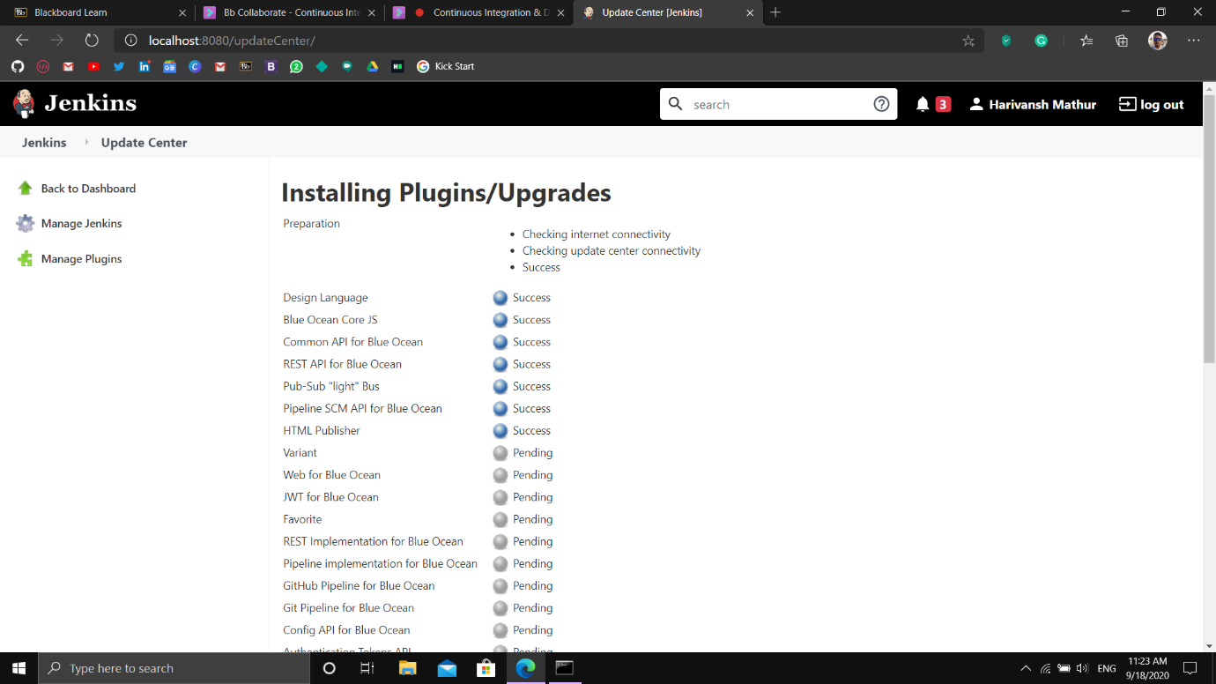

Installing the Blue Ocean Plugin in Jenkins

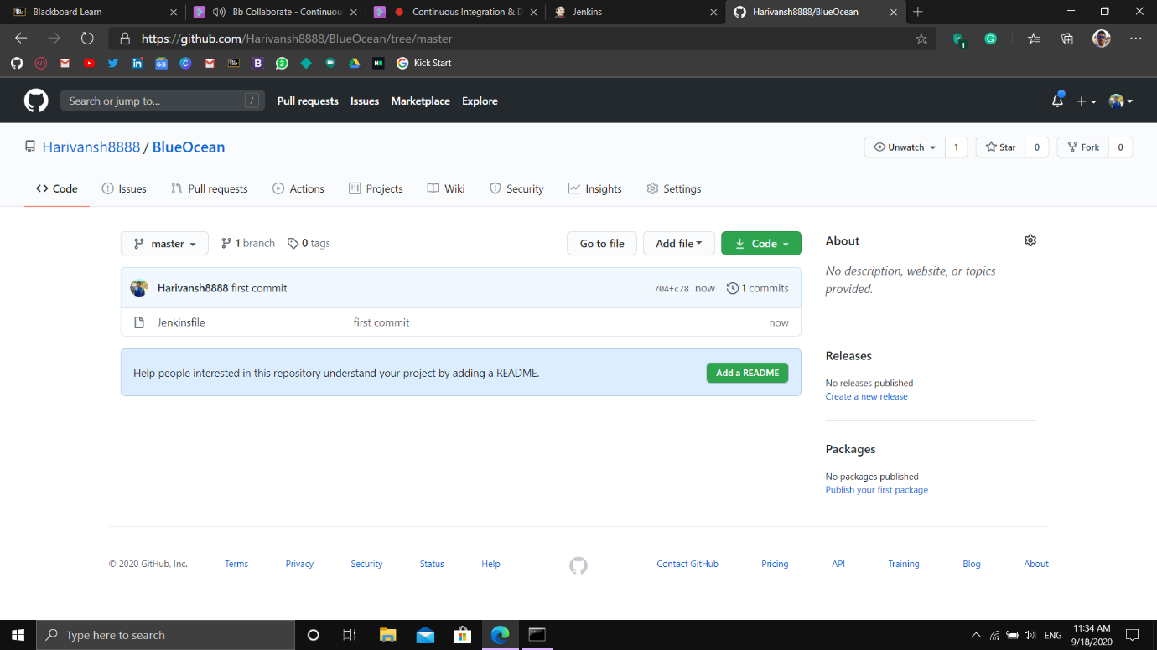

Storing the Jenkinsfile in a repository on my GitHub

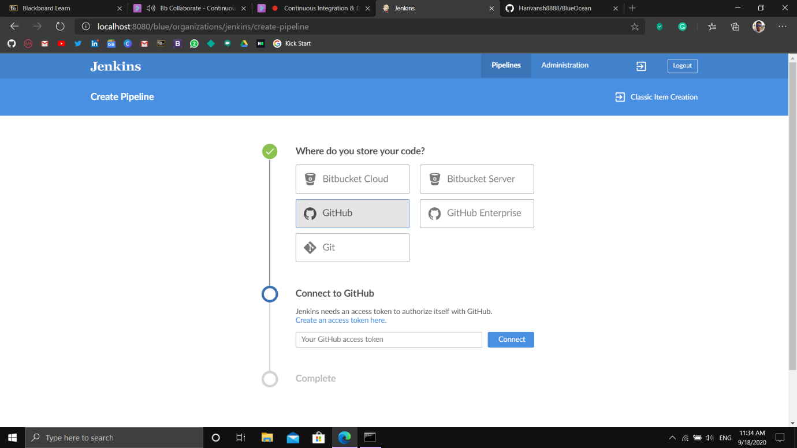

Giving Blue Ocean access to my GitHub account

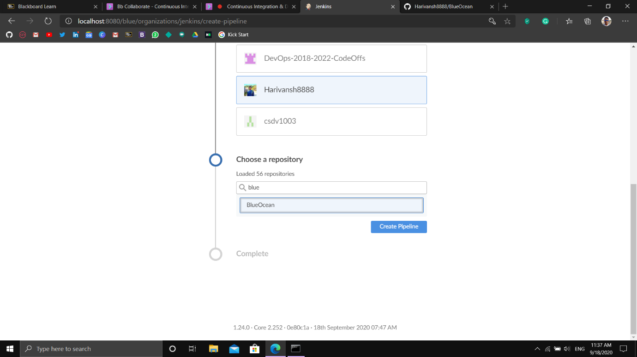

Selecting the appropriate repository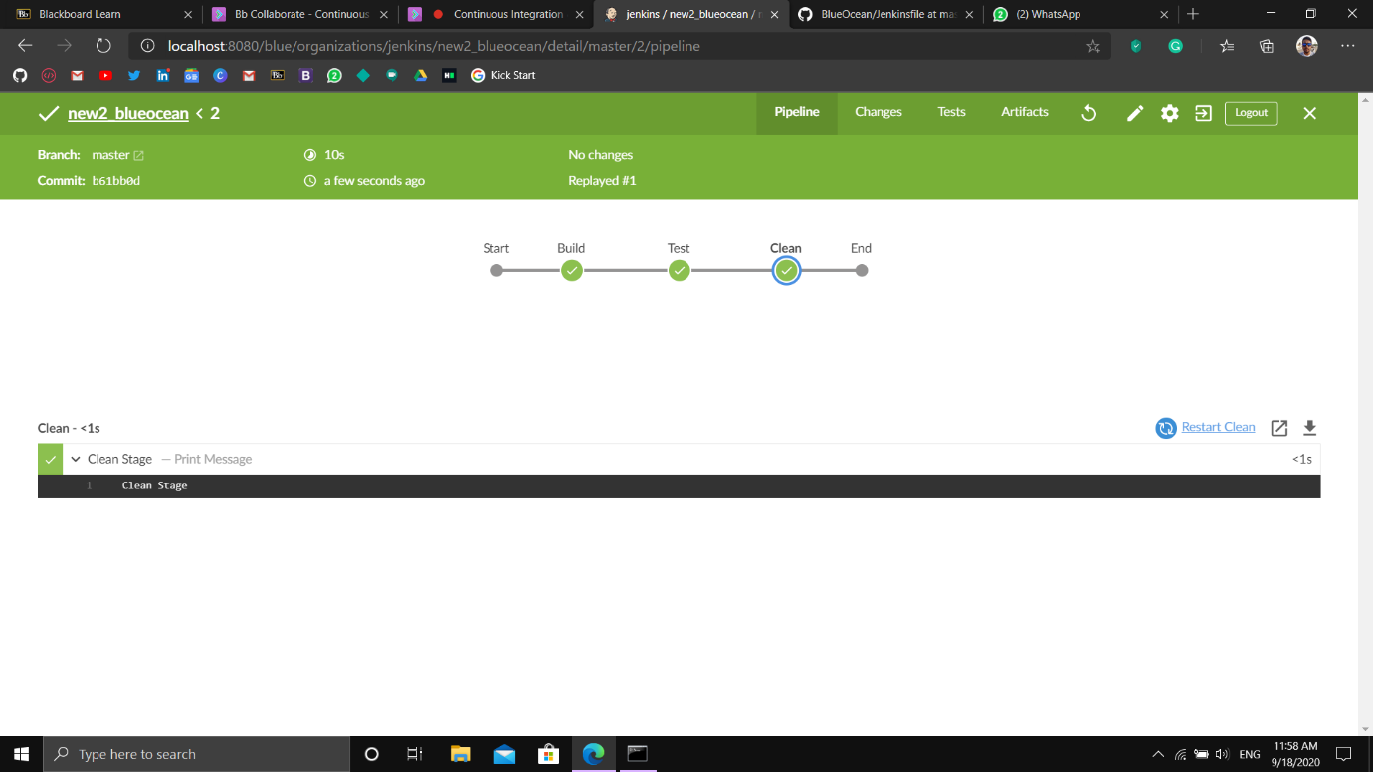Finally executing the Jenkinsfile using Blue Ocean